Assignment 2:   
Date: 24/1/25

PRN: 22510039

1)MySQL review:-

Test_table :-

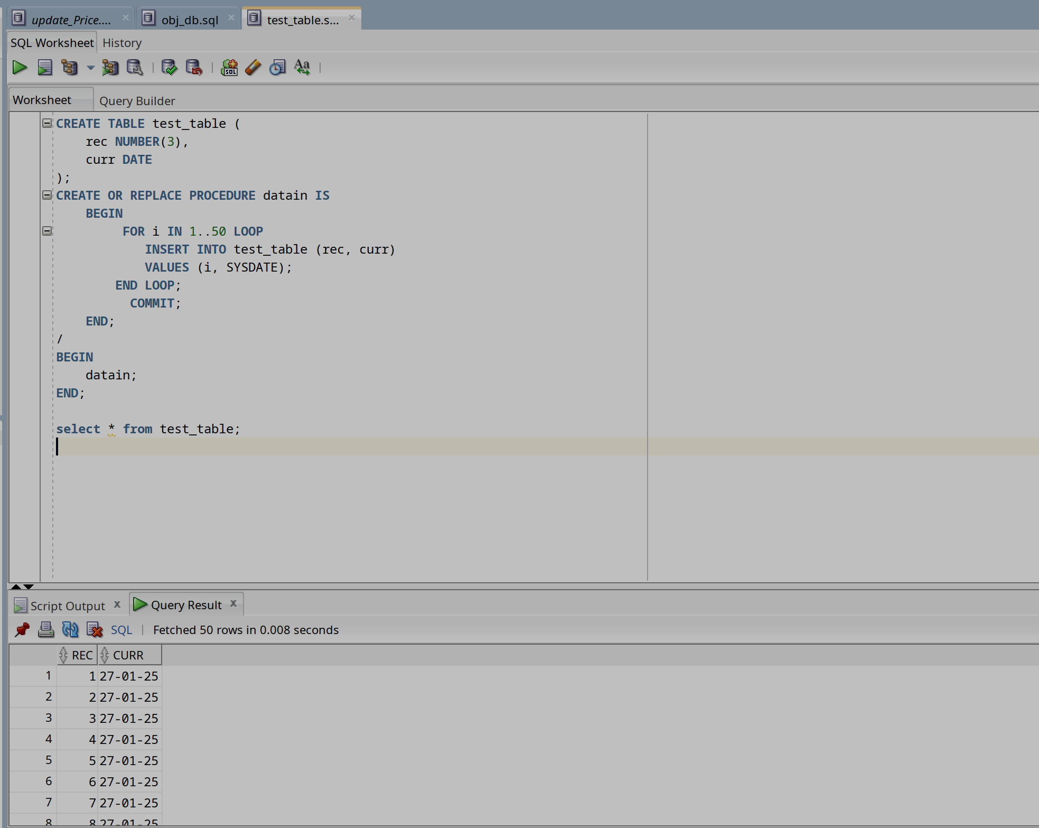  
  
b) Update price:-   
  
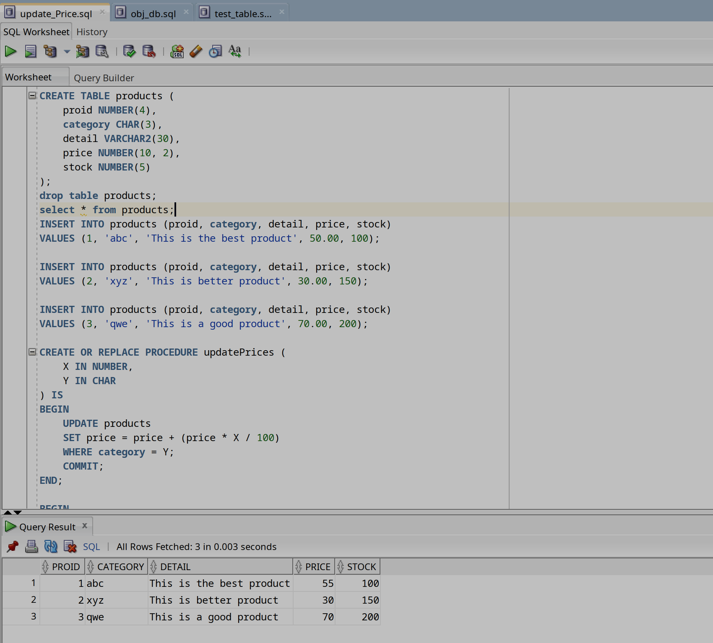

2) Object Relation:-   
a)  
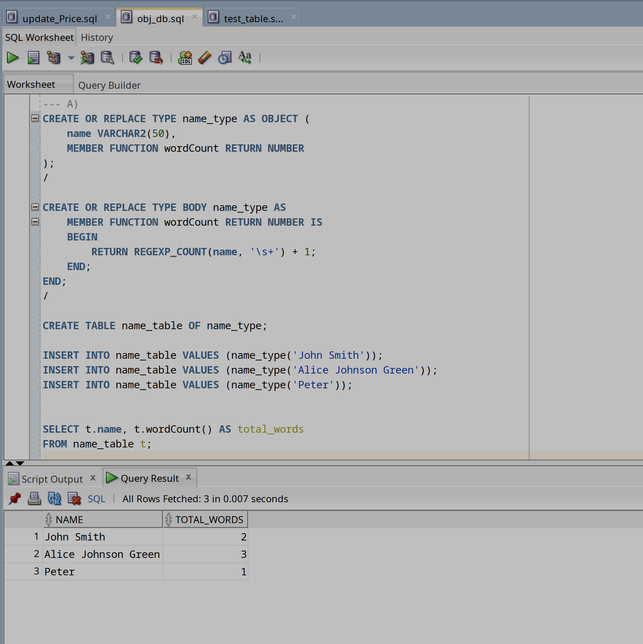

b)

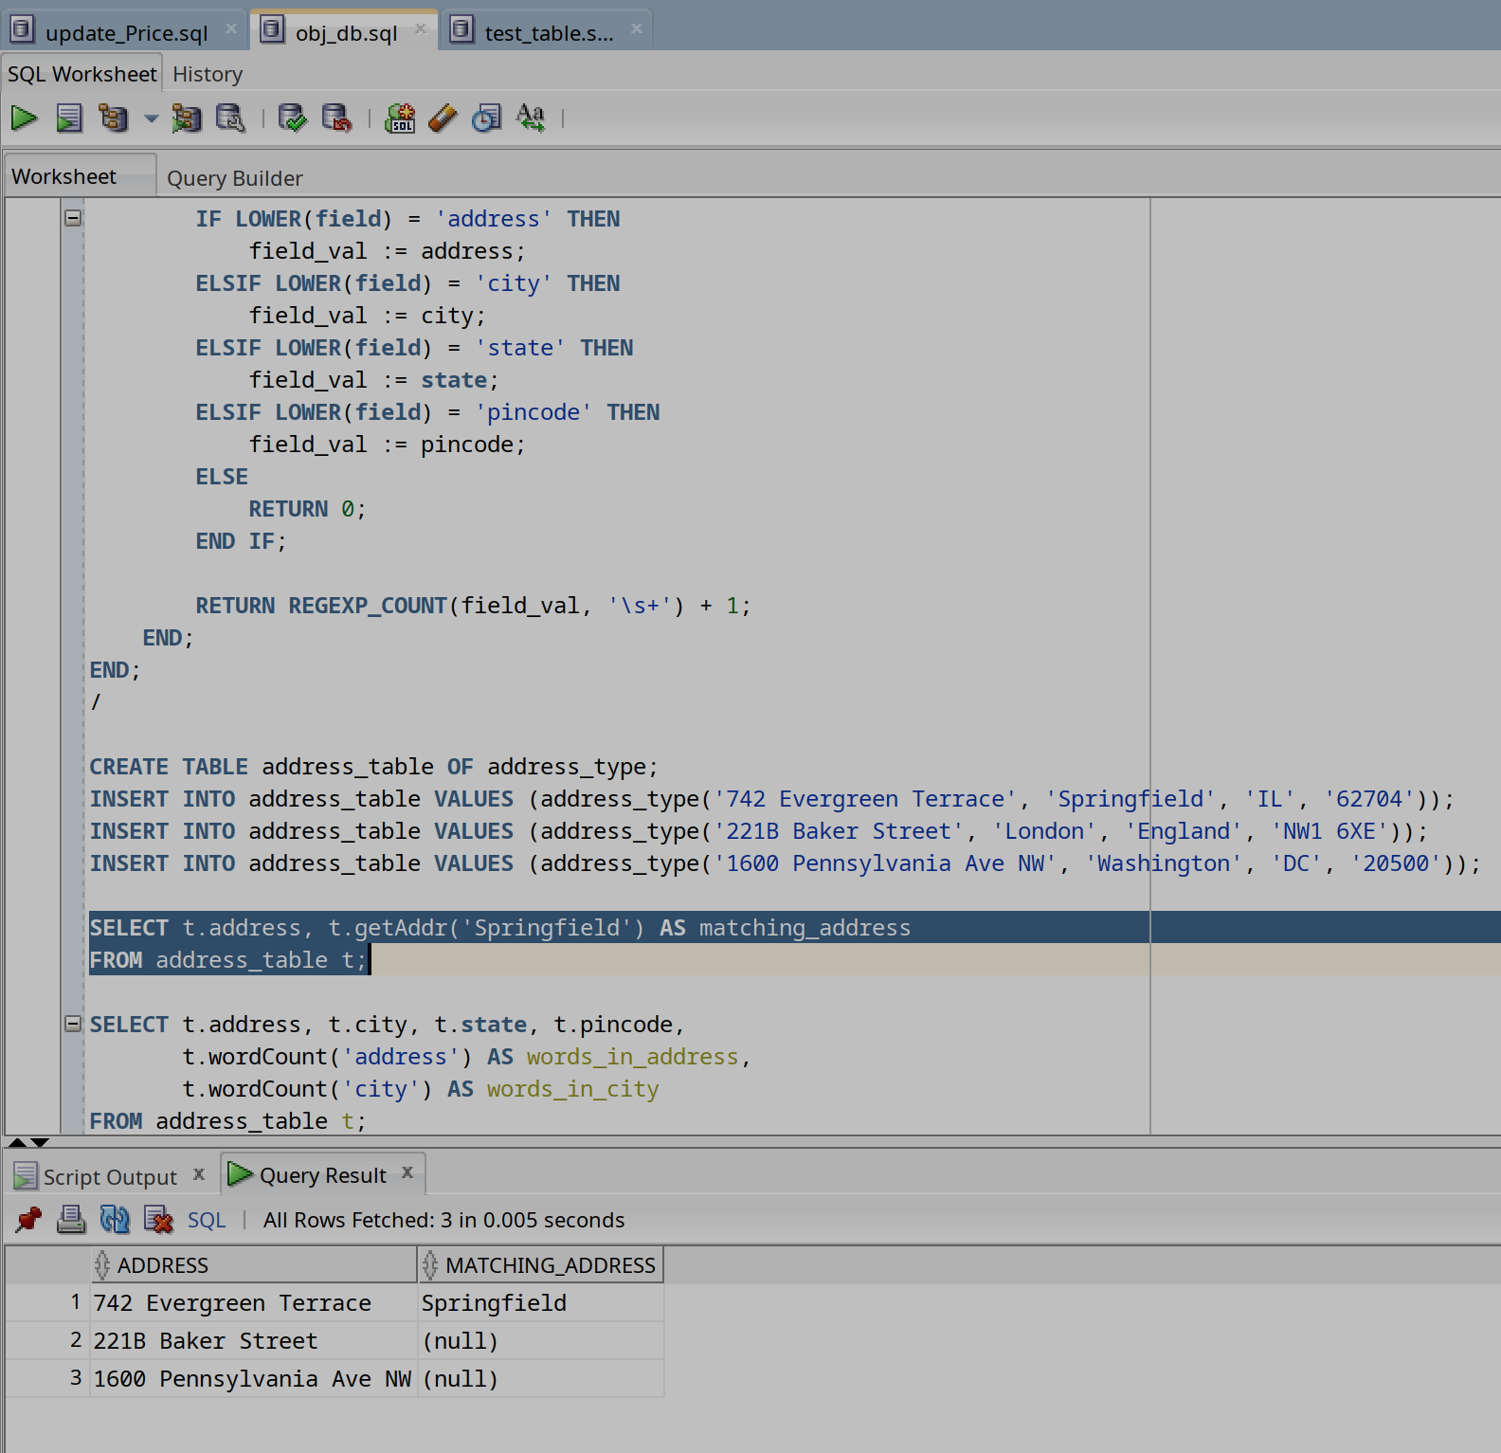  
  
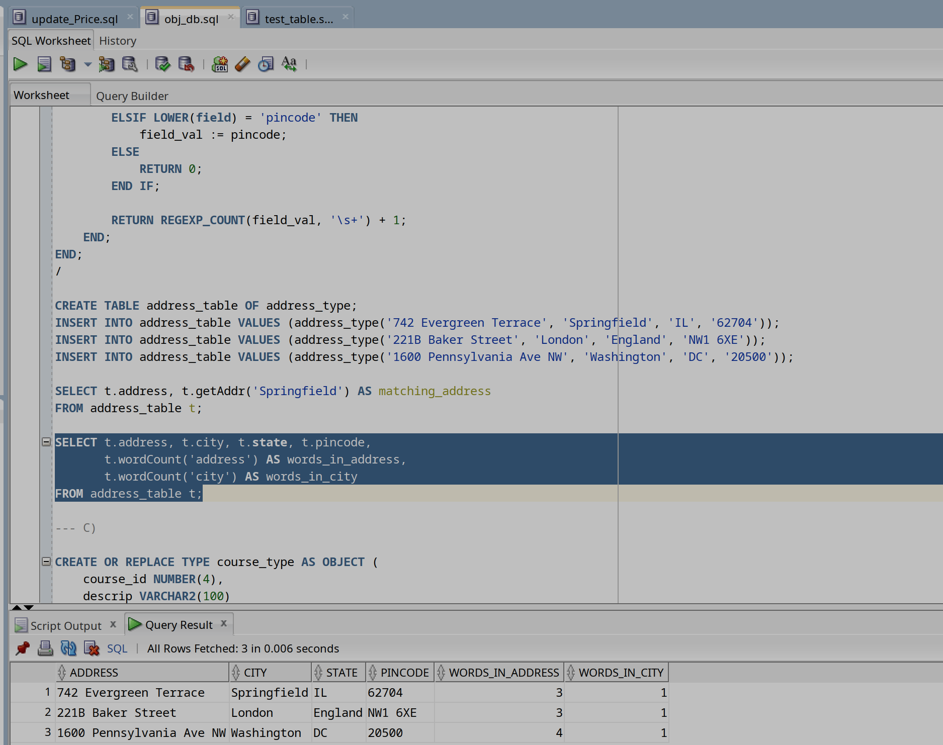  
  
c)

